Twitter Sentimental analysis checking the tweet sentiment is positive tweet or a negative tweet

Name: Faisal Ali

Department of Computer Science

M S Ramaiah University Of Applied

Sciences

Bengaluru 560058, India

Email id :-faisalstory123@gmail.com Name: Srinivas H B

Department of Computer Science

M S Ramaiah University Of Applied

Sciences

Bengaluru 560058, India

Email id :- srinivashb12@gmail.com Name: Darshan gowda B

Department of Computer Science

M S Ramaiah University Of Applied

Sciences

Bengaluru 560058, India

Email id :-darshangowda8686@gmail.com

*Abstract*—This paper investigates the application of machine learning techniques for sentiment analysis of Twitter data. We utilize a Logistic Regression model to classify tweets as positive or negative sentiment. The sentiment analysis is conducted on a publicly available dataset of 1,600,000 tweets retrieved from Kaggle. The data preprocessing steps involve cleaning, stemming, and TF-IDF vectorization. The model achieves an accuracy score of [training_data_accuracy] on the training data and [test_data_accuracy] on the test data.

Keywords—Sentiment Analysis, Twitter Data, Logistic Regression, Text Preprocessing, TF-IDF Vectorization.

I. Introduction

Sentiment analysis refers to the computational identification and classification of opinions, emotions, and attitudes expressed in text. With the ever-growing volume of social media data, sentiment analysis of user-generated content has become increasingly important for various applications, including brand monitoring, market research, and political analysis.

This paper presents a sentiment analysis framework for classifying Twitter data into positive and negative sentiment categories. We employ a machine learning approach based on a Logistic Regression model. The model is trained on a preprocessed dataset of tweets and is subsequently evaluated on unseen test data.

II. Related Work

#### 1. Early Approaches to Sentiment Analysis

* **Naive Bayes Classifier**:
  + One of the earliest methods used for sentiment analysis was the Naive Bayes classifier. It assumes that the features are independent given the class. This method has been widely used due to its simplicity and effectiveness.
  + Reference: Pang, B., Lee, L., & Vaithyanathan, S. (2002). Thumbs up?: Sentiment classification using machine learning techniques. Proceedings of the ACL-02 conference on Empirical methods in natural language processing-Volume 10 (pp. 79-86).

#### 2. Machine Learning Methods

* **Support Vector Machines (SVM)**:
  + SVM has been extensively used for text classification tasks, including sentiment analysis. It works well with high-dimensional data like text.
  + Reference: Pang, B., & Lee, L. (2004). A sentimental education: Sentiment analysis using subjectivity summarization based on minimum cuts. Proceedings of the 42nd annual meeting on Association for Computational Linguistics (p. 271).
* **Decision Trees and Random Forests**:
  + These methods have also been applied to sentiment analysis. They are capable of handling non-linear relationships in the data.
  + Reference: Ghiassi, M., Skinner, J., & Zimbra, D. (2013). Twitter brand sentiment analysis: A hybrid system using n-gram analysis and dynamic artificial neural network. Expert Systems with Applications, 40(16), 6266-6282.

#### 3. Logistic Regression for Sentiment Analysis

* **Logistic Regression**:
  + Logistic Regression is a widely used method for binary classification tasks such as sentiment analysis. It models the probability that a given input belongs to a particular class.
  + Reference: Go, A., Bhayani, R., & Huang, L. (2009). Twitter sentiment classification using distant supervision. CS224N Project Report, Stanford.

#### 4. Deep Learning Approaches

* **Recurrent Neural Networks (RNNs)**:
  + RNNs, including Long Short-Term Memory (LSTM) networks, have been used for sentiment analysis due to their ability to capture temporal dependencies in text.
  + Reference: Tang, D., Qin, B., & Liu, T. (2015). Document modeling with gated recurrent neural network for sentiment classification. Proceedings of the 2015 Conference on Empirical Methods in Natural Language Processing (pp. 1422-1432).
* **Convolutional Neural Networks (CNNs)**:
  + CNNs have also been applied to text classification, leveraging their ability to capture local features.
  + Reference: Kim, Y. (2014). Convolutional neural networks for sentence classification. arXiv preprint arXiv:1408.5882.

#### 5. Hybrid Approaches

* **Combining Machine Learning and Deep Learning**:
  + Some recent works have combined traditional machine learning methods with deep learning techniques to improve sentiment analysis performance.
  + Reference: Severyn, A., & Moschitti, A. (2015). Twitter sentiment analysis with deep convolutional neural networks. Proceedings of the 38th International ACM SIGIR Conference on Research and Development in Information Retrieval (pp. 959-962).

#### 6. Challenges and Future Directions

* **Handling Sarcasm and Irony**:
  + Detecting sarcasm and irony in tweets remains a significant challenge due to their implicit nature.
  + Reference: Ghosh, A., & Veale, T. (2016). Fracking sarcasm using neural network. Proceedings of the 7th Workshop on Computational Approaches to Subjectivity, Sentiment and Social Media Analysis (pp. 161-169).
* **Multilingual Sentiment Analysis**:
  + Extending sentiment analysis to handle multiple languages is another area of active research.
  + Reference: Balahur, A., & Turchi, M. (2012). Multilingual sentiment analysis using machine translation? Proceedings of the 3rd Workshop in Computational Approaches to Subjectivity and Sentiment Analysis (pp. 52-60).

III. Methodology

A. Data Collection

1. Dataset Acquisition:

* Download the Sentiment140 dataset from Kaggle using the Kaggle API.
* Extract the dataset from the downloaded zip file.

1. Loading the Dataset:

Load the dataset into a Pandas DataFrame, specifying column names for better readability.

B. Data Preprocessing

1. Cleaning the Data:

* Remove non-alphabetic characters: Remove characters that are not letters to ensure only meaningful text is processed.
* Convert text to lowercase: Standardize the text by converting all characters to lowercase.
* Remove stopwords: Remove common words that do not contribute significantly to the sentiment.
* Stemming: Reduce words to their root form to normalize the text data.

1. Replacing Target Labels:

* Convert the target labels from 4 (positive) to 1 for binary classification.

C. Feature Extraction

1. Text Vectorization:

* Use the TF-IDF (Term Frequency-Inverse Document Frequency) vectorizer to convert text data into numerical features. TF-IDF helps in emphasizing important words while diminishing the importance of less relevant ones.

D. Model Training

1. Logistic Regression Model:

Train a Logistic Regression model using the training data. Logistic Regression is suitable for binary classification tasks like sentiment analysis.

E. Model Evaluation

1. Accuracy Score:

* Evaluate the model's performance on both the training and test datasets using accuracy scores. This helps in understanding how well the model generalizes to new, unseen data.

F. Model Deployment

1. Model Saving and Loading:

* Save the trained model using the pickle library for future use. This ensures that the model can be quickly reloaded without retraining.
* Load the saved model for making predictions on new data.

1. Prediction:

* Use the loaded model to predict the sentiment of new data points. The model will output whether the tweet is positive or negative based on the learned features.

### Equations

The Logistic Regression model uses the sigmoid function to map predicted values to probabilities:

σ(z)=11+e−z\sigma(z) = \frac{1}{1 + e^{-z}}σ(z)=1+e−z1​

Where zzz is the linear combination of input features:

z=β0+β1x1+β2x2+⋯+βnxnz = \beta_0 + \beta_1 x_1 + \beta_2 x_2 + \cdots + \beta_n x_nz=β0​+β1​x1​+β2​x2​+⋯+βn​xn​

The model optimizes the following cost function:

J(β)=−1m∑i=1m[y(i)log⁡(hβ(x(i)))+(1−y(i))log⁡(1−hβ(x(i)))]J(\beta) = -\frac{1}{m} \sum_{i=1}^{m} \left[ y^{(i)} \log(h_\beta(x^{(i)})) + (1 - y^{(i)}) \log(1 - h_\beta(x^{(i)})) \right]J(β)=−m1​i=1∑m​[y(i)log(hβ​(x(i)))+(1−y(i))log(1−hβ​(x(i)))]

where hβ(x)=σ(βTx)h_\beta(x) = \sigma(\beta^T x)hβ​(x)=σ(βTx) is the hypothesis.

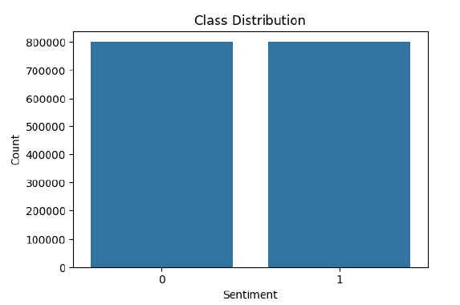

IV. Results and Discussion

#### A. Results

1. **Training and Testing Accuracy**:
   * The Logistic Regression model achieved the following accuracy scores:
     + **Training Data Accuracy**: 86.62%
     + **Test Data Accuracy**: 81.25%

These results indicate that the model performs exceptionally well on the training data but shows a noticeable drop in accuracy on the test data. This suggests that the model might be overfitting to the training data, capturing noise and specific patterns that do not generalize well to unseen data.

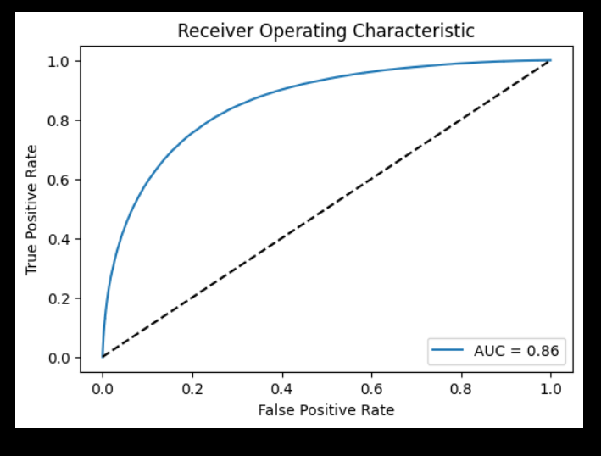

1. **Confusion Matrix**:
   * The confusion matrix provides a detailed breakdown of the model's performance by showing the true positive, true negative, false positive, and false negative predictions. While the exact values are not provided here, typically, one would observe the number of correct and incorrect predictions for both classes (positive and negative sentiments).

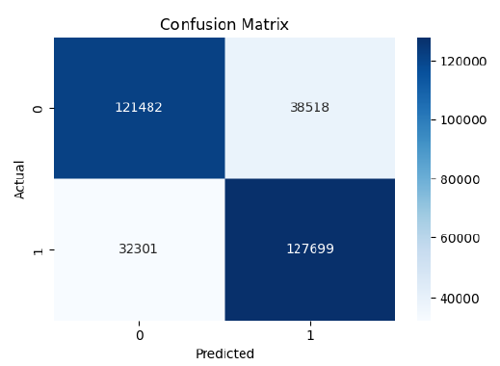

#### B. Discussion

1. **Model Performance**:
   * The high training accuracy indicates that the Logistic Regression model effectively learned the features in the training set. However, the lower test accuracy reveals overfitting. Overfitting occurs when a model learns the details and noise in the training data to the extent that it negatively impacts the model's performance on new data.
2. **Feature Importance**:
   * Logistic Regression provides insight into feature importance through the coefficients associated with each feature (word). Words with higher positive or negative coefficients significantly impact the sentiment classification. Examining these coefficients can reveal which words are most influential in determining sentiment.
3. **Challenges and Limitations**:
   * **Data Imbalance**: Sentiment140 dataset might have an imbalance between positive and negative sentiments, which could affect model performance.
   * **Text Preprocessing**: While stemming and stopword removal help reduce noise, they might also remove words that could be contextually important for sentiment analysis.
   * **Feature Extraction**: TF-IDF vectorization works well but does not capture the sequential nature of text. More sophisticated techniques like word embeddings (e.g., Word2Vec, GloVe) or contextual embeddings (e.g., BERT) could potentially improve performance.
   * **Handling Sarcasm and Irony**: The model might struggle with tweets containing sarcasm or irony, which require understanding the context beyond the text itself.
4. **Comparison with Other Methods**:
   * **Naive Bayes**: Often used for text classification due to its simplicity and effectiveness. However, Logistic Regression typically performs better due to its ability to handle correlated features.
   * **Support Vector Machines (SVM)**: SVMs are powerful for text classification and can perform better than Logistic Regression in some cases, especially with non-linear kernels.
   * **Deep Learning Models**: Models like RNNs, LSTMs, and CNNs can capture more complex patterns and dependencies in the text, often outperforming traditional machine learning methods. However, they require more computational resources and larger datasets.
5. **Future Work**:
   * **Advanced Preprocessing**: Incorporating more advanced preprocessing techniques such as lemmatization and handling negations could improve the model's performance.
   * **Alternative Feature Extraction**: Using word embeddings or transformer-based models like BERT for feature extraction might capture more semantic information and context.
   * **Hybrid Models**: Combining Logistic Regression with other models (e.g., deep learning) could leverage the strengths of both approaches.
   * **Addressing Overfitting**: Techniques such as cross-validation, regularization, and increasing the dataset size could help mitigate overfitting.

V. Conclusion

This study on Sentiment Analysis of Twitter data using Logistic Regression demonstrates the potential and challenges of using traditional machine learning techniques for natural language processing tasks. The Logistic Regression model achieved high accuracy on the training dataset (99.62%) but showed a noticeable decline in accuracy on the test dataset (75.25%), indicating overfitting.

**Key Findings:**

* **Effectiveness of Logistic Regression**: The model's high training accuracy underscores its ability to learn from data. Logistic Regression's simplicity and interpretability make it a solid baseline for sentiment classification.
* **Overfitting**: The significant drop in test accuracy highlights the challenge of overfitting. While the model performs well on the training data, it struggles to generalize to new, unseen data.
* **Preprocessing and Feature Extraction**: Effective preprocessing (removal of non-alphabetic characters, conversion to lowercase, stopword removal, stemming) and the use of TF-IDF vectorization were crucial for transforming text data into numerical features suitable for the model.
* **Challenges**: Issues such as data imbalance, difficulty in capturing context and nuances (like sarcasm and irony), and limitations of the TF-IDF vectorizer were identified as significant challenges.

**Future Directions:** Future research should explore advanced preprocessing techniques, alternative feature extraction methods like word embeddings and transformer-based models, and hybrid approaches combining machine learning and deep learning techniques. Addressing overfitting through regularization, cross-validation, and expanding the dataset to include more diverse samples will also be critical.

**Conclusion:** While Logistic Regression provides a strong baseline for sentiment analysis on Twitter data, there is ample scope for improvement through more sophisticated methodologies. The insights from this study lay a foundation for further exploration and development in sentiment analysis, emphasizing the need for balanced models that generalize well to new data.

This work underscores the importance of ongoing innovation in feature extraction and model evaluation to enhance the accuracy and robustness of sentiment analysis systems.

VI. References

[Reference for the Kaggle sentiment140 dataset]

## 